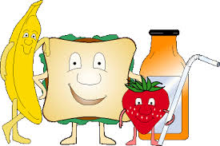
THE SNACK SHACK CAN CANTEEN NEWS
Summer Extra Menu Items Term 4 2021
Hot Dog (97% fat free hotdog with sauce) $3.50
Hot Dog & Cheese (97% fat free hotdog with cheese & sauce)
$4.00
Summer Chicken Burger (grilled chicken patty lettuce pineapple cheese & sauce) $4.50
Summer Beef Burger (grilled beef patty lettuce beetroot cheese & sauce) $4.50 Small Chicken Salad Wrap (lettuce,tomato,carrot,cheese) $3.20
Small Ham Salad Wrap (lettuce,tomato,carrot,cheese) $3.20
Small Salad Wrap (lettuce ,tomato, carrot, cheese) $2.00
Chicken Tender Slider (wrap ,lettuce & mayo) $3.00
Chicken Tender Slider (wrap ,lettuce, cheese & sauce) $3.20
Chicken Tender Slider (Cheese & Sauce) $3.00
Potato Gems Oven Baked 10 Pack $1.00
Oven Baked Hash Brown $1.50
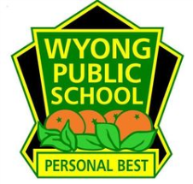
Thank You For Your support

