EARLY START
Warm Cheese & Ham Roll $2.00
Hot Milo $1.00
Pikelets Plain, Butter or Jam $0.40
House Made Muffins Blueberry, Apple cinnamon $0.50
Hot Ham & Cheese Pocket $1.00

HOT FOOD (Orders Only)
Large Chicken Tenders $1.30
Chicken Wedges (each) $0.90
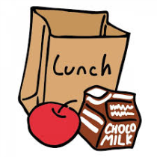
Corn Cob $1.00
Lean Sausage Roll $3.00
Lean Small Pie $2.50
Lean Large Pie $3.80
TOMATO/ BBQ SAUCE $0.40
In House Pizza: $4.00
- BBQ Sauce, Chicken & Cheese
- Salsa, Ham, Pineapple, Cheese
-Salsa & Cheese V
Ham, Cheese, Wrap (toasted) $4.00
Hot Chicken & Gravy Roll $4.20
Pasta Tomato Salsa & Cheese V $4.00
Pasta Bolognaise & Cheese $4.50
Lasagne $4.50
Fried Rice GF HM $4.00
Vegie & Hokkien Noodle Stir Fry V HM $3.50
Add Chicken $4.50
Nachos –Tomato Salsa & Cheese GF V $4.00
Nachos – Beef & Cheese GF $4.50

CREATE YOUR OWN SNACK SHACK BURGER $5.00
Choose from: Lean Beef Patty/Grilled Chicken Patty
Choose Your Salad and Sauce Lettuce/tomato/Carrot/Cucumber/Beetroot/Pineapple/Cheese/Mayo/BBQ/Tomato or Sweet Chilli

Chicken & Cheese Burger Chicken Patty Cheese Sauce $4.00

Cheese Burger Lean Beef Patty Cheese & Sauce $4.00

Gluten Free = GF.
V = Vegetarian
Please state on lunch bag any food allergies

SANDWICHES WRAPS & ROLLS
All can be toasted
White rolls & Wraps (extra) $0.60
Vegemite/ Honey/ Jam $2.00
Cheese/ Baked Beans/ Spaghetti/Egg & Mayo $2.50
Ham/ Chicken/ Tuna $3.00
Extra Filling:
Lettuce/Tomato/Carrot/Cucumber/Pineapple/Beetroot/ Cheese each $0.50

Basic Salad Sandwich V $3.50
(Lettuce, Tomato, Carrot, Cucumber, Cheese).
Add: Ham/ Chicken/ Tuna $1.00

Chicken Wedge Wrap (Wedges,Lettuce,Tomato,Carrot,Cheese)
Sauce Sweet Chilli/BBQ/Tomato Sauce/ Mayo $4.50
CREATE YOUR OWN SALAD BOX GF V
Small $4.50 Large $5.50
Choose from:
Lettuce/ Tomato/ Carrot/ Cucumber/ Pineapple/ Corn/
Beetroot/ Cheese.
Add:
Ham/ Chicken/ Tuna/ Whole Egg $1.00
Beef or Chicken Patties $2.00

Caesar Salad Small $4.50 Large $5.50
(Lettuce, Lean Ham, Cheese, Egg, Croutons, Caesar Dressing)
Add: Chicken $1.00
GLUTEN FREE OPTIONS
Gluten free Chicken Tenders each $1.30
Chicken Tender with Small Salad $5.50
Parents are welcome to bring in Gluten Free cupcakes for birthday parties, bread for sandwiches. We can also heat pies and Sausage rolls. Simply place in a container with name & class clearly marked and we will store in our freezer.

WYONG WEEKLY $3 DEALS
Please check the board at the front of the canteen to see the weekly dollar deal
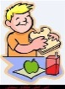
These deals will combine food and small drink and will be changed weekly.

ALL DAY SNACKS
Ham & cheese Pocket $1.00
Vegemite or Garlic Scrolls Small (house made)V $0.20
Warm Macaroni & Cheese Cups Lrg $1.00

Fresh Fruit Salad OR Watermelon Cups Sm $1.00
Lge $1.60
Mixed Grape cups $1.00
Fresh Fruit $1.00
Red Rock Deli Chips Sea Salt $1.50
Popcorn Plain GF V $1.00
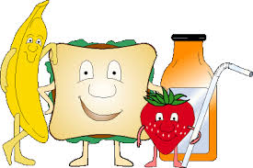
Hummus &Vegie Sticks V GF $1.20
Hummus & Corn Chips V GF $1.20
Custard Cups GF $1.00

DRINKS AVAILABLE ALL DAY
Fruit Cups (Apple & Blackcurrant) GF $1.00
Water 300mls $1.00
Water 600mls $2.00
Flavoured Milk Light 300ml $2.20
(Chocolate, Strawberry)
Juice 250ml (Apple, ABC & Orange) $2.00
Hot Milo $1.00
Slushy 99% Fruit Juice $2.00
Fruit smoothie seasonal fruit & Honey GF $1.50

FROZEN TREATS
Frozen Fruit Cups (Apple, ABC) GF $1.00
Vanilla Ice Cream Cups GF $1.00
Frozen Chunky Fruit Kebabs (seasonal) $1.00
Quelch Fruit Sticks (99% Juice) HALF $0.30 FULL $0.50
Juicie Tubes 98% Fruit Juice (Tropical, Berry) $1.20
Moosies ( Chocolate, Blue Moon) $1.20
Frozen Juice Pops $0.10

WYONG PUBLIC SCHOOL CANTEEN MENU 2021

Canteen
Online Order System

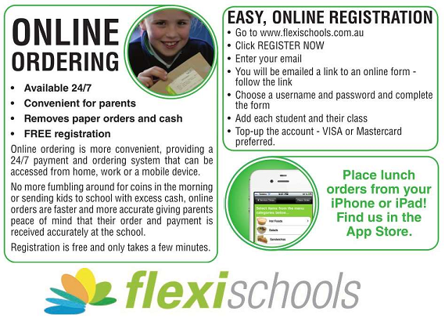

Wyong Public School

Canteen Menu

2021
