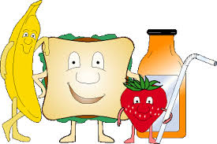
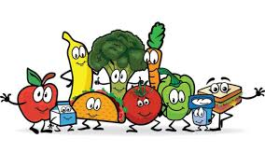
\ THE SNACK SHACK CAN CANTEEN NEWS
Summer Extra Menu Items Term 4
Light Vanilla Yogurt with Mixed Berries or Mango Cup Sm $1.00
Lrg $1.50
Fresh Chunky Fruit Kebabs $1.00
Frozen Chunky Fruit Kebabs $1.00 Butter Chicken & Rice $4.50
Honey Soy Chicken & Rice $4.50
Chicken & Cheese Burger (chicken,patty,cheese,sauce) $3.50
Small Chicken Salad Wrap (lettuce,tomato,carrot,cheese) $3.00
Small Ham Salad Wrap (lettuce,tomato,carrot,cheese) $3.50
Small Salad Wrap (lettuce ,tomato, carrot, cheese) $2.00
Chicken Tender Slider (wrap ,lettuce & mayo) $3.00
Chicken Tender Slider (wrap ,lettuce, cheese & sauce) $3.20
Chicken Tender Slider (Cheese & Sauce) $3.00
Potato Gems Oven Baked 10 Pack $1.00
Oven Baked Hash Brown $1.50
Chicken Tender Wrap (lettuce,tomato,carrot,cheese,sauce) $5.00
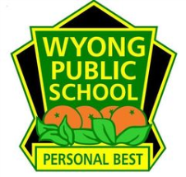
Thank You For Your support

