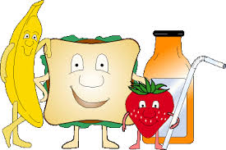
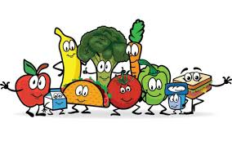
THE SNACK SHACK CAN CANTEEN NEWS
Summer Menu Items Term 1
Mixed Berries & Vanilla Yoghurt Cups small $1.00 Lge $1.50
Mango & Vanilla Yoghurt Cups small $1.00 Lge $1.50
Chunky Fresh Fruit Kebabs $1.00
Garlic Bread Loaf $2.00
Potato Bake w/ Ham (potato, cheese, ham, peas & corn) $4.00
Lean Potato Topped Pie Large $3.60
Lean Potato Topped Pie Small $2.60
Chicken & Cheese Burger (chicken patty cheese & sauce) $3.50
Small Salad Wrap (lettuce, tomato, carrot, cheese) $2.00
Chicken Tender Slider (wrap, lettuce & mayo) $3.00
Chicken Tender Slider (wrap, lettuce, cheese & sauce) $3.20
Chicken Tender Slider (Cheese & Sauce) $2.80
Potato Gems Oven Baked 10 Pack $1.00
97% Fat Free Hot Dog (Tomato, BBQ, Sweet Chilli sauce) $3.60
97% Fat Free Hot Dog & Cheese (Tomato, BBQ, Sweet chilli) $4.00
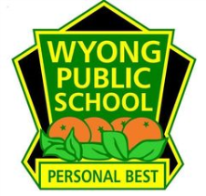
Thank You For Your Support

